ICD-100: Bus to Payload Power Interface
1. Document Control
- Document Number: SDSU-SB+-ICD-100
- Revision: v2.0
- Date: April 2026
- Owner: SDSU Payload Team

2. Purpose
This document defines the electrical power interface between the spacecraft bus (EPS) and the SDSU payload subsystem, including RILA, ZES, and supporting sensors. It establishes voltage levels, current limits, distribution architecture, and verification requirements.

3. Scope
This ICD governs:
- Bus power delivery to payload
- Internal payload power distribution via ZES
- Power sequencing and control behavior
- Grounding and protection requirements

4. Power Architecture Overview
Primary Power Flow:
- EPS → 5 V → ZES (primary controller)
- EPS → 12 V → RILA (science instrument)
Secondary Distribution:
- ZES → 3.3 V → Magnetometer, Accelerometers, RS-422 converter

5. Electrical Requirements
5.1 Power Requirements Table
Component | Voltage | Nominal Current | Peak Current | Notes
RILA | 12 V ±0.5 V | ~30 mA | ~42 mA | Direct EPS supply
ZES | 5 V ±5% | 120–200 mA | ≤500 mA | Main controller
Magnetometer | 3.3 V | ≤15 mW | ≤65 mW | via ZES
ADXL355 | 2.25–3.6 V | low | TBD | via ZES
MS1002 | 3.2–3.4 V | 2.3 mA | 4 mA | via ZES

6. Power Sequencing
- ZES shall power on first
- ZES logic must stabilize before sensor enable
- RILA power may be controlled via ON/OFF signal or bus command
- Safe-mode condition → payload power disabled

7. Grounding & Bonding
- All payload elements share a common ground
- Ground reference established at ZES input
- RS-422 cable shields terminated at ZES side only
- Star grounding topology recommended

8. Protection & Limits
- ZES input voltage shall not exceed 5.25 V
- UART logic shall not exceed 3.6 V
- RILA input shall not exceed 13 V
- RS-422 converter shall include ESD protection
- ADC/sensor inputs protected against overvoltage

9. Verification
Tests
- Power rail validation (5 V / 12 V)
- Current draw measurement
- Power sequencing validation
- Safe-mode shutdown test
- Thermal behavior under load
Acceptance Criteria
- Voltage within tolerance
- Current within expected range
- No unexpected resets or overcurrent

10. Physical Electrical Interface Definition
This section defines the physical implementation of the payload electrical interface, including connector pin assignments, signal mapping, and subsystem connectivity. All signals are defined at the pin level to enable direct implementation without additional clarification.

10.1 ZES Connector Pin Mapping (H1 Header)
The ZES board interfaces to payload subsystems via a 52-pin header (H1). The following table defines all relevant signals used for payload integration.
Pin | Signal Name | Direction | Voltage Level | Connected To | Interface Type | Notes
34 | GND | — | 0 V | Bus Ground | — | Common ground reference
37 | ZES RESET | Input | 3.3 V | OBC | Digital | System reset control
38 | ZES TX | Output | 3.3 V | RILA RX | UART | Primary payload UART
39 | ZES RX | Input | 3.3 V | RILA TX | UART | Primary payload UART
40 | ESCL | Output | 3.3 V | Accelerometers | I²C | I²C clock line
41 | ESDA | Bidirectional | 3.3 V | Accelerometers | I²C | I²C data line
42 | MISO | Input | 3.3 V | Reserved | SPI | Not used in current configuration
43 | SCK | Output | 3.3 V | Reserved | SPI | Not used in current configuration
44 | MOSI | Output | 3.3 V | Reserved | SPI | Not used in current configuration
48 | ZES D0 (RX) | Input | 3.3 V | Magnetometer TX | UART | Secondary UART input
49 | ZES D1 (TX) | Output | 3.3 V | Magnetometer RX | UART | Secondary UART output
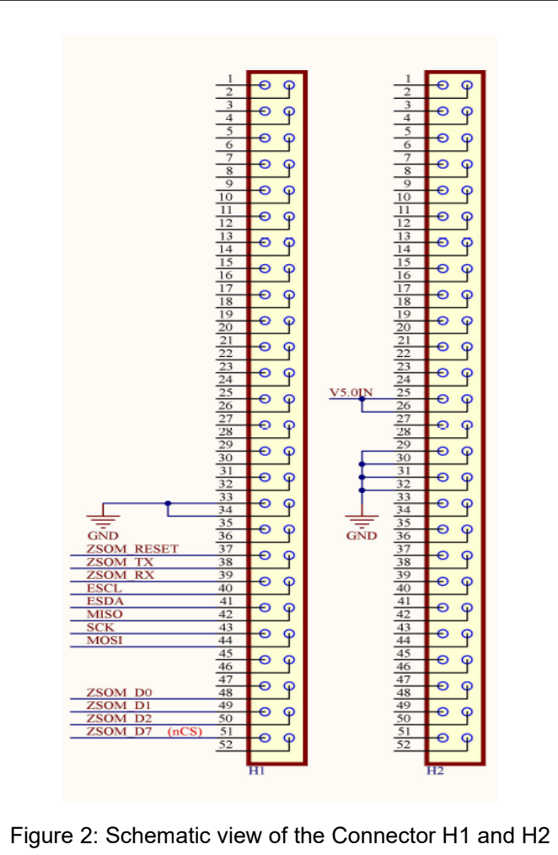

Interface Voltage Note
All digital interface pins (UART, I²C, SPI, GPIO) operate at 3.3 V logic levels and are not 5 V tolerant.

10.2 Subsystem Interface Mapping
The following defines how each payload subsystem connects to the ZES board:
RILA Dosimeter
- Interface: UART (via RS-422 to UART transceiver)
- Connections:
  - RILA TX → ZES RX (Pin 39)
  - RILA RX → ZES TX (Pin 38)
- Power: 12 V supplied directly from EPS

Magnetometer
- Interface: UART (via RS-422 to UART transceiver)
- Connections:
  - Magnetometer TX → ZES D0 (Pin 48)
  - Magnetometer RX → ZES D1 (Pin 49)
- Power: 3.3 V supplied via ZES

Accelerometers (ADXL355, MS1002)
- Interface: I²C
- Connections:
  - ESCL (Pin 40) → Sensor SCL
  - ESDA (Pin 41) → Sensor SDA
- Power: 3.3 V supplied via ZES

Test Configuration (Non-Flight Hardware)
During ground testing, an Arduino-based RILA emulator outputs 5 V UART signals. A voltage divider is used to step down the signal to 3.3 V before entering the ZES RX pin.
In the flight configuration, RILA communicates via an RS-422 to UART transceiver operating at 3.3 V logic levels.

10.3 Connector and Interface Standard
- ZES board utilizes dual 52-pin header connectors (H1/H2)
- Payload wiring shall interface through PCB headers and harness connectors
- Final flight connectors (e.g., Micro-D or equivalent) shall be selected prior to integration
- All connectors shall include mechanical retention features to withstand launch vibration environments

10.4 Power Interface Pin Definition
Signal | Source | Destination | Voltage | Notes
5V Rail | EPS | ZES | 5 V ±5% | Primary controller power
12V Rail | EPS | RILA | 12 V ±0.5 V | Science instrument power
3.3V Rail | ZES | Sensors | 3.3 V | Internal distribution

10.5 Cable and Harness Implementation
- All cables shall be routed using secured harnesses
- No free-floating wires permitted
- Minimum bend radius shall be maintained
- RS-422 lines shall use twisted-pair wiring
- Shielding shall be applied to all high-speed or differential lines
- Harness tie-down spacing shall prevent movement under vibration
- Harness routing shall avoid proximity to high-current lines and sensitive sensors (e.g., magnetometer) to minimize EMI coupling

10.6 Grounding and Return Path Definition
- All payload subsystems shall share a common ground reference
- Ground return paths shall be low-impedance and continuous
- RS-422 shield shall be grounded at ZES side only
- Star grounding topology shall be used to minimize noise coupling
- No floating grounds are permitted

10.7 Electrical Protection Requirements
ZES Power Input
ZES shall be powered by a regulated 5 V supply (±5%). The input voltage shall not exceed 5.25 V.
ZES Signal Inputs
All ZES digital interface signals (UART, I²C, GPIO) operate at 3.3 V logic levels. Input signals shall not exceed 3.6 V.
Any external device operating at 5 V logic (e.g., Arduino) shall use voltage level shifting or a voltage divider before interfacing with ZES.
Additional Protection
- RILA input voltage shall not exceed 13 V
- All interfaces shall include ESD protection
- Overcurrent protection shall be implemented at EPS level
- Sensor inputs shall be protected against voltage transients

10.8 Interface Verification Requirements
The following tests shall verify correct electrical interface implementation:
- Power rail validation (5 V and 12 V)
- Current draw measurement under nominal and peak load
- Power sequencing validation
- Connector continuity testing
- Harness inspection and strain relief verification
- Ground continuity verification

10.9 Power vs Signal Interface Clarification
Power interfaces and signal interfaces are treated separately:
- Power interfaces supply operating voltage to payload components (5 V and 12 V)
- Signal interfaces are limited to 3.3 V logic levels and are used for communication
Mixing of power and signal definitions is not permitted within this interface specification.

